Name: Sergio Gutierrez

bitbucket Repo: <https://bitbucket.org/SergioZGutierrez/homework/src/master/>

Homework 3

Folder containing homework 3:

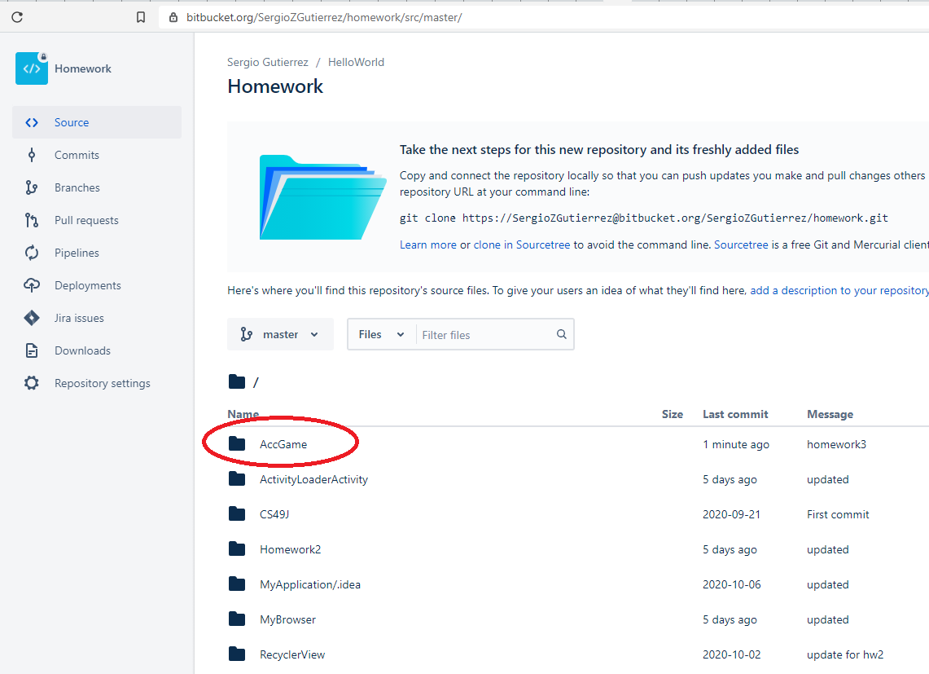

Homework 3:

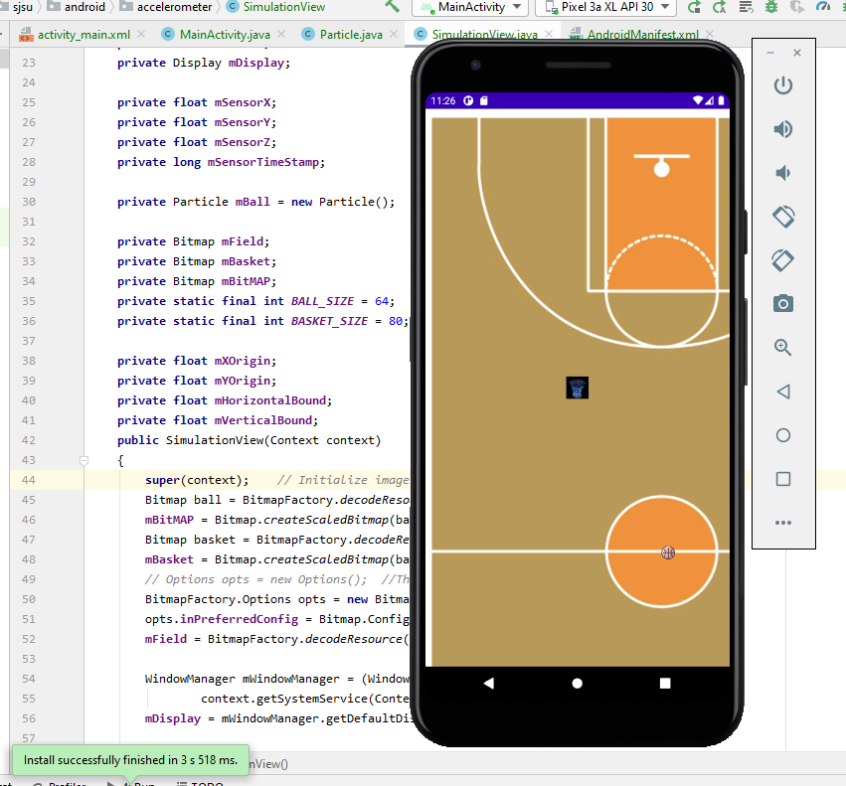

The exact pathway of where the .java files are located in my repository are:

<https://bitbucket.org/SergioZGutierrez/homework/src/master/AccGame/app/src/main/java/edu/sjsu/android/accelerometer/>